ONLINE CLOTHING

System Design

1.0

11.12.16

Tahir Onural Tekizbaş

Prepared for

SE301 Software Engineering



Table of Contents

1. Introduction 2

1.1. Purpose of the System 2

1.2. Design Goals 2

1.3. Definitions, Acronyms, and Abbreviations 3

1.4. References 3

2. Current Software Architecture 3

3. Proposed Software Architecture 3

3.1. Overview 4

3.2. System Decomposition 4

3.3. Hardware Software Mapping 6

3.4. Persistent Data Management 7

3.5. Access Control and Security 4

3.6. Global Software Control 4

3.7. Boundary Conditions 4

4. Subsystem Services 4

5. References 5

SYSTEM DESIGN DOCUMENT[1]

The System Design Document (SDD) is written after the initial system decomposition is done, and updated throughout the development. SDD describes the services provided by each subsystem. Although this section is usually empty or incomplete in the first versions of the SDD, this section serves as a reference for teams for the boundaries between their subsystems. The interface of each subsystem is derived from this section and detailed in the Object Design Document.

SDD is used to define interfaces between teams of developers and serve as a reference when architecture-level decisions need to be revisited. The audience for the SDD includes the project management, the system architects (i.e., the developers who participate in the system design), and the developers who design and implement each subsystem.

# Introduction

## Purpose of the System

Online clothing facilitates transportation costs. It removes all traffic, park, store store trolleys, pay-per-view waiting and package handling problems altogether. They let you know.

The ability to see and compare all the features of the products at the same time and to decide whether to buy all of the processes in stages and to quit.

online clothing, finding the right products or services, and seeing a lot of alternatives without tiring the bazaar market gives you the opportunity to find and buy quickly

to sum up ,it is considered as a convenient method to find those things which are hard to find made it a time saving method.

## Design Goals

**Maintainability**; our website can be maintained by managers.

**Understandability:** because of our web site design, this web site is easy to use. Our web site’s interface is clear for users and managers.

**-Efficiency;** it is about performance , and efficient for speed , not for space. Because , speed and space are inversely proportional.

**-Depandability;**

**Criterias for depandability;**

**Availability:** Our system is always available. Because customers can always give order.

**Reliability:** admin, user, product, order, etc. information which is used our web site is stored in MySQL database and have unique id , this situation decreases error level.

**Security:** In this web site we use **C**lient – **S**erver **M**odel, in this situation, server gives us database server service. our system keeps and protects informations. This condition makes our web page more secure.

**Safety:** Each customer can only access their own information. And also everyone with internet and computer can order, it does not harm people etc.

## Definitions, Acronyms, and Abbreviations

ID:  **Id**entification

RAD: **R**equirement **A**nalysis **D**ocument

SDD: **S**ystem **D**esign **D**ocument

HTML: **H**yper **T**ext **M**arkup **L**anguage

PHP: **H**ypertext **P**reprocessor **P**age

CSS: **C**ascading **S**tyle **S**heets

MySQL: **My** **S**tructured **Q**uery **L**anguage

CSM: **C**lient – **S**erver **M**odel

## References

Trendyol.com,

Markofoni.com

This two websites are references for our project.To desing interfaces and use tools such as shopping box etc.

# Current Software Architecture

Our project is an online clothing program that is easy to use for our customers. Our site is useful with clear guidance. While creating this project, Our goal is to deliver the clothes that our customers have chosen to their homes without using a credit card with the best possible service as soon as possible. You can choose any product on our site, our products only serve in İstanbul. We have categories for male and female customers on our website. After you have selected your products, you will be redirected to the payment page.

We are in the implemention part.

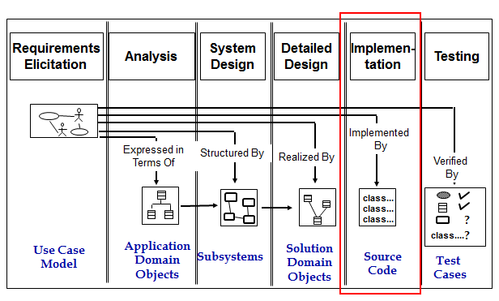

# Proposed Software Architecture

## Overview

Our system is divided into four subsystems. These are User, Visitor, Product Manager and Admin. The user have to sign up for any data related to clothes just for buying. The visitor can see the products but also need to sign up for shopping. The admin contains the acces of admin on the application. The admin can change primary and improtance activities. Admin has the ability for update any information about products. And last module is for product manager controls the biggest part of the system. All products, orders and sales. Our system is able to provide high cohesion low coupling condition so that the system can work efficiently. Because the more interconnection between items, the stronger the communication with each other. The external connection, ie, the coupling is kept to a minimum, the complexity is minimized. The whole system is adversely affected by connection confusion in the external system.

## System Decomposition

In softtware decomposition our application is harboring some main components. According to hierarchy there are different interfaces for user login, admin login, and product manager login. Users will see and control their own page after they log in. And we have four subsystem.

Admin subsystem controls product manager subsystem and user subsystem. Product manager can be added and deleted and users can be deleted by the admin. Admin can view about products details but cannot control.

Product Manager subsystem contols all product, categories and orders. Product Manager can add, delete, update products and categories , and view users’ orders. Product Manager can view the sent products for delivery status.

Visitor subsystem can only view all products , categories and can search. Visitor can not buy any product.

User subsystem can view all products , categories and can search. User can add product to shopping box and delete product from shopping box and can give orders. User can view himself /herself user informations and can update. User can view his/her orders.

database decomp:

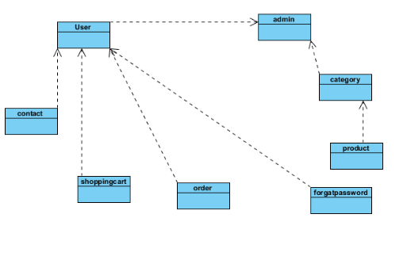

software decomp:

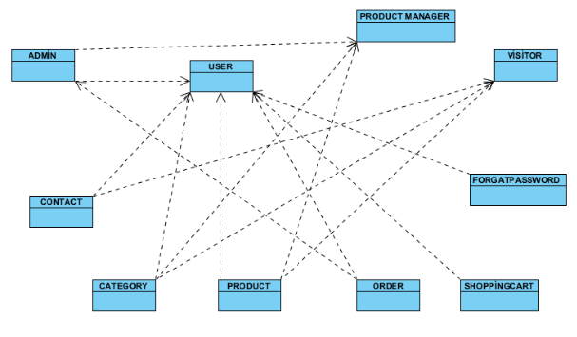

## Hardware Software Mapping

When the user logs in, our application connects to a web server. There can be multiple users. Accessing simultaneously is provided by the web server. The user's pc connects web server with Http.

The web server connects to the database .Our application-side with connecting to the web server, database classes in mySQL responds to user requests.

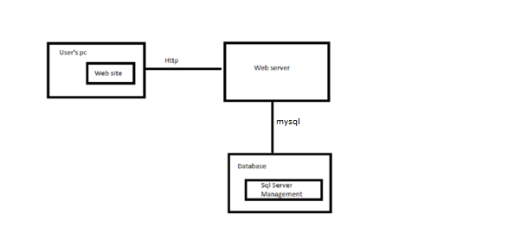

## Persistent Data Management

All data are to be stored in MySQL database which have 8 table which are “admin”, “category”, “contact”, “forgatpassword”, “order”, “product”, “shoppingcart”, “user”. Login Information of manager is stored form “admin” table, and admin table is used to Authentication for manager. “Category” table is used to store categorize product. If users write message, contact table is used to store massages which were written us. “forgatpassword table”, if our costumer forget his / her password, our costumer writes us, and we want to write his / her user name, first name, last name , email address. These values are insert in “forgatpassword table”. “product table” is used to store product information, which we have. Our customer wanted to give order and he / she add cart which is wanted to buy, order which is added in shopping is stored in “shoppingcart” table which have **username, product_name, product_price**. In our payment page this table is used to list shopping cart. Order which is given by all costumers is stored in “order” table. And finally, our customers are stored in “user” table. “user” table is used to Authentication for customers.

**Admin**



**Category**



**Contact**



**forgatpassword**



**order**



**product**



**shoppingcart**



**user**



ALL TABLES



## Access Control and Security

Matrix:

|  |  |  |  |  |
| --- | --- | --- | --- | --- |
|  | **Admin** | **Product Manager** | **User** | **Visitor** |
| **Stockroom** | DisplayStockRoom |  |  |  |
| **Order** | DisplayOrders  UpdateOrders  DisplayOrdere | DisplayOrders  UpdateOrders |  |  |
| **Manager** | AddManager  DeleteManager  Update Manager  DisplayManager |  |  |  |
| **User** | AddUser  DeleteUser  UpdateUser  DisplayUser |  |  |  |
| **Product** |  | AddProduct  DeleteProduct  UpdateProduct  SearchProduct | DisplayProductList  AddToCart | DisplayProductList |
| **Category** |  | AddCategory  DeleteCategory  UpdateCategory | DisplayCategories | DisplayCategories |
| **Contact** |  | ShowContactList | WriteMassageContactForm | WriteMassageContactForm |
| **ForgatPassword** |  | ShowForgatPasswordList | WriteMassageContactForm | WriteMassageContactForm |

## Global Software Control

Users can purchase any product which they want in stock after enter the system. Address information is not requested in the payment process since the address information is received in the first user registration. The product will be shipped to the customer address with cargo. . And more than one user can access the system at the same time. Two customers can choose the same product. If there is one product in stock , deadlock will occur. Thread will be used for the deadlock that occurred. Therefore the product will be buy by selected first. Generally , threads are used in http.

## Boundary Conditions

Users can access the categories and products after logging into the system. They can choose the product that they want to buy from categories, products list or search. After you select a product, the purchase processing starts. If you want to purchase a product, you should log on to the website , if you’re a user, this is not necessary. If you make any mistakes, you can direct to main page. There is no credit limit check because there is no credit card payment.

# Subsystem Services

Admin and product manager logins with use MySQL database with admin table Admin have authorization to show order and stockroom, and admin can insert, delete, and update manager and also user. And admin can show orders and gain from orders. Product manager has more authority than admin. Product manager can insert, delete, and update product and category. Information of category is stored in category table and Information of product is stored in product table. Product Manager can show contact and forgat password. If User contacts us when user writes his / her details, these details are saved contact table. And product manager can show these massage to use contact table from database. For forgat password, forgatpassword table is used. And information of category is stored category table. Admin and product manager logins with use MySQL database with user table User can show category, product, add to cart which product user want to buy. categories, and products are showed with use category and product table. When user add to cart, these values are inserted shoppingbox table. Visitor can only show categories and products.

# References

1) http://blog.slickedit.com/2007/05/how-to-write-an-effective-design-document/

2) https://www.digitalunite.com/guides/shopping-banking/online-shopping/internet-shopping-how-buy-online

3) Bruegge B. &DutoitA.H.. (2010). *Object-Oriented Software EngineeringUsing UML, Patterns, and Java*, Prentice Hall, 3rded.

4) Eric J. Braude, Michael E. Bernstein, Software Engineering: Modern Approaches 2/e Wiley, 2011 (online pdf-sdd formats)

5)Emine Ekin 2016 Fall Lecture Slides (how to design Access Matrix)